Work package number |  |  | WP-TA1 |  |  |  | start date of event: |  |  |  |  |  | M6 |  | end date of event: |  |  |  |  | M48
Work package title |  |  | Transnational access @ NTNU
Activity Type |  |  | SUPP
Participant number | 1
Participant short name | NTNU

Description of the infrastructure
Name(s) of the infrastructure(s)*: | NTNU MEMB-FAB , NTNU MEMB-PERM, ABSKIN,ABSDEG, ABSEQ
Location (town, country): | NORWAY
Web site address: | www.ntnu.no
Legal name of organisation operating the infrastructure: |  |  | Norges
Location of organisation (town, country): |  | Trondheim. Norway
Annual operating costs (excl. investment costs) of the infrastructure (€): |  |  |  | 800 000

TA1.1 NTNU MEMB-FAB (Capture, Membranes)

Description of the facilities
This infrastructure provides facilities and methods to fabricate polymer-based membranes in lab scale and pilot scale, including the spinning of hollow fiber membranes, carbonization to prepare carbon membranes and coating of thin composite membranes on flat sheet or hollow fiber supports. The facilities are listed below with pictures in Figure 1:
- Spinning machine for hollow fiber fabrication and coating
- Carbonization rig
- Pilot scale flat sheet coating device
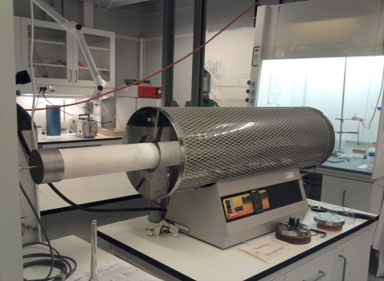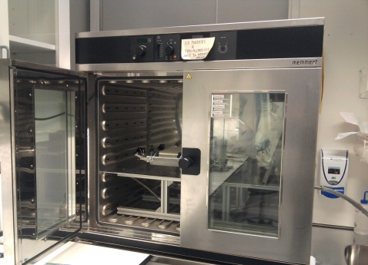
Figure 1. Pictures of the spinning machine (left), carbonization rig(middle) and the pilot scale flat sheet coating device(right)
The replacement costs for the Infrastructure (€): 500,000

TA1.2 NTNU MEMB-PERM(Capture, Membranes)
This infrastructure provides facilities and methods to test membrane gas permeation performance in lab scale and pilot scale in different conditions, including single gas, mixed gas, gas separation in humidified conditions and at high pressures, with both flat sheet or hollow fiber membrane modules. The facilities are listed below with pictures in Figure 2:
- Membrane gas permeation test rig for single gas and mixed gas (GC for gas composition analysis)
- Membrane gas permeation test rig for mixed gases at humidified conditions (GC for gas analysis)
- Membrane gas permeation test rig for mixed gases at high pressures (MS for gas composition analysis)

Figure 2. Pictures of membrane gas permeation test rig for single/mixed gas(left), membrane permeation test rig for humidified conditions(middle) and membrane permeation test rig for mixed gas at high pressures (right)
The replacement costs for the Infrastructure (€): 800,000

State of the art for TA1.1 and TA1.2
- In the TA1.1 NTNU MEMB-FAB infrastructure, the well-equipped facilities support broad techniques for the fabrication of polymer-based membranes, providing researchers the opportunity for ‘one-stop’ work in developing novel membranes of various materials or unique morphology that enhance the CO2 separation performance. The facilities are updated and easy to operate, which enables users to conduct high quality researches.
- In the TA1.2 NTNU MEMB-PERM infrastructure, the facilities provided are advance and updated, equipped with automatic controlling and indication system as well as devices for auto-sampling and auto data-recording, providing researchers the opportunity to test membrane gas permeation performances in different conditions with reliable and high quality data.

Services currently offered by the infrastructures TA1.1 and TA 1.2 and achievements
- There is a widespread interest from users in other countries to conduct research in developing new and more efficient membranes for CO2 separation, and in testing gas permeation of membranes in different conditions. During recent years, researchers from our international partners from Italy, France, USA and China have also used the facilities.
- The current users at NTNU have obtained many scientific achievements based on the services offered by the infrastructures, including EU projects, industrial and NFR projects, 5 patents and more than 30 papers:

EU funded projects: NaturalHy, Ulcos, Engas, NanoGlowa, etc.
Other large initiatives: SINTEF- NCSU (2 projects), NFR, Statoil, Alstom project, RECCO2 (NFR, Statoil for KMB and BIP projects)
Selected patents:
- M. Sandru, T-J Kim, M.-B. Hagg, Gas separation membrane, WO2010086630A1, 2010.
- Liyuan Deng, May-Britt Hägg, Taek-Joong Kim, CO2 capture membrane, European patent EP1897607, EP1900419 and US Patent US2008078290
- Hägg MB, Lie, JA; Carbon Membranes, WO2007017650A
Selected publications:
- Shao, L, Samseth, J, Hagg MB; Crosslinking and stabilization of nanoparticle filled PMP nanocomposite membranes for gas separations; J.Membr.Sci., 326 (2) 285-292 (2009)
- M.Sandru, S.H. Haukebø, M-B Hägg, Composite hollow fiber membranes for CO2 capture, J.Membr.Sci., 346 (2010) 172-186
- He, Xuezhong, Hägg MB, Structural, Kinetic and Performance Characterization of Hollow Fiber Carbon Membranes, submitted to J.Membr.Sci, April 2011

TA 1.3 Kinetic studies (ABSKIN) (CO₂ capture, absorption)
The package offers a possibility to measure absorption kinetics with string of discs apparatus and with wetted wall column. Both apparatuses are suitable for loaded and unloaded solutions. The String of discs can be used up to 70ºC and the wetted wall column can be used up to 80ºC. Additionally measurement of viscosity, density and physical solubility of CO₂ using N₂O analogy measurement can be measured.

TA1.4 Solvent degradation laboratory (ABSDEG) (CO₂ capture, absorption)
Solvent degradation laboratory makes it possible to study fundamental solvent degradation. This installation includes 3 apparatuses. The oxidative degradation in closed-batch reactor is suitable for degradation studies at absorber temperatures (45-60ºC) whereas the thermal degradation tests can be done up to 135ºC. Additionally with a new screening apparatus for oxidative degradation, it is easy to test inhibitors and effect of metal. The degradation laboratory has a closed co-operation with analytical laboratory with SINTEF Biotechnology which does most of the analytical work.

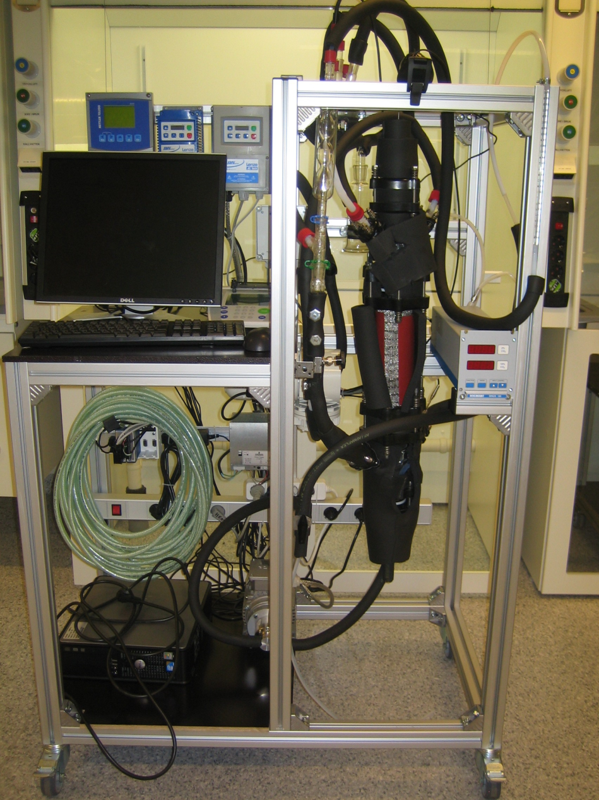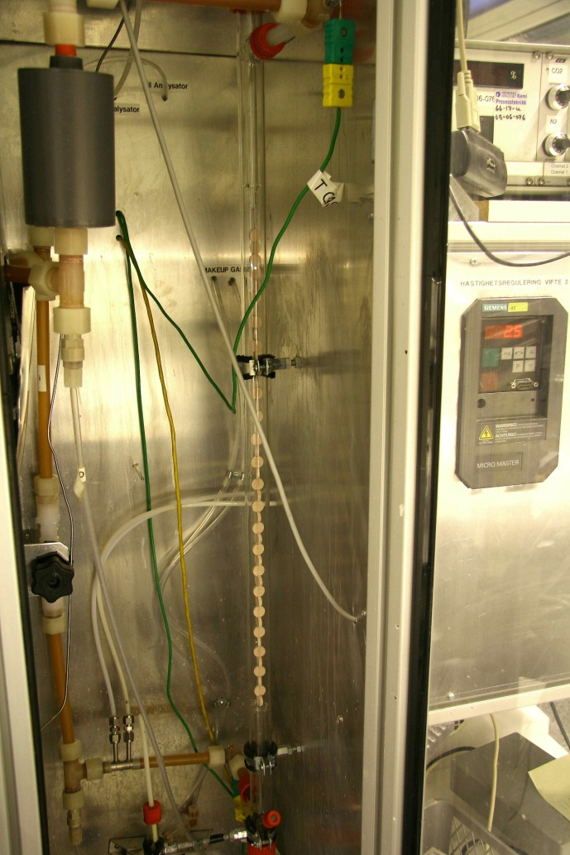
Figure 3 Oxidative degradation apparatus (left) and string of discs apparatus (right).

TA1.5 Thermodynamic studies (ABSEQ) (CO₂ capture, absorption)
The installation includes 5 different apparatuses. The low temperature VLE apparatus can be used to measure vapor-liquid equilibrium of loaded absorption liquids up to 80ºC and up to 35 vol% CO₂. In high temperature VLE, the VLE up to 120 ºC can be measured. And an apparatus for liquid-solid equilibrium studies is available. The high pressure VLE apparatus is able to provide VLE information up to 20MPa. The reactor calorimeter is suitable for heat of reaction measurements under pressures from -1 to 100 bar gauge and temperatures of from -20 to 200 ºC.

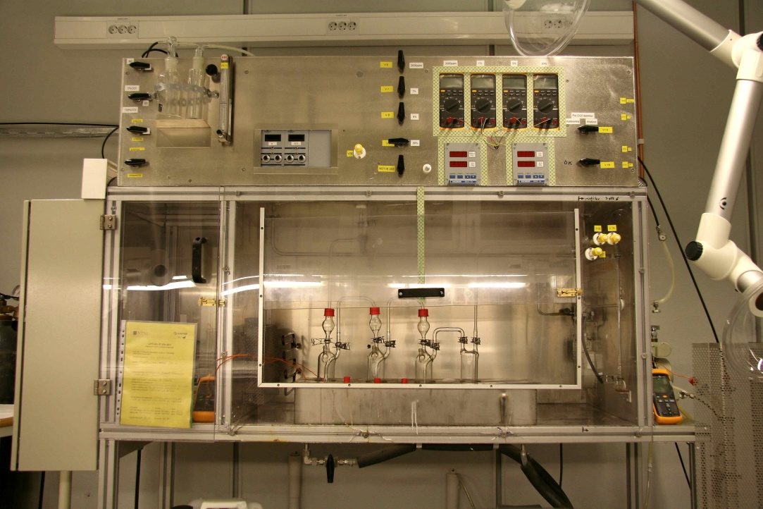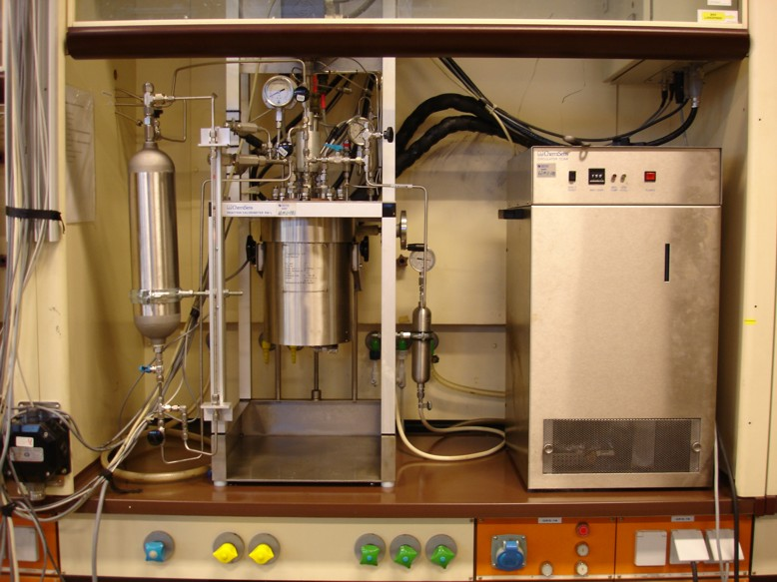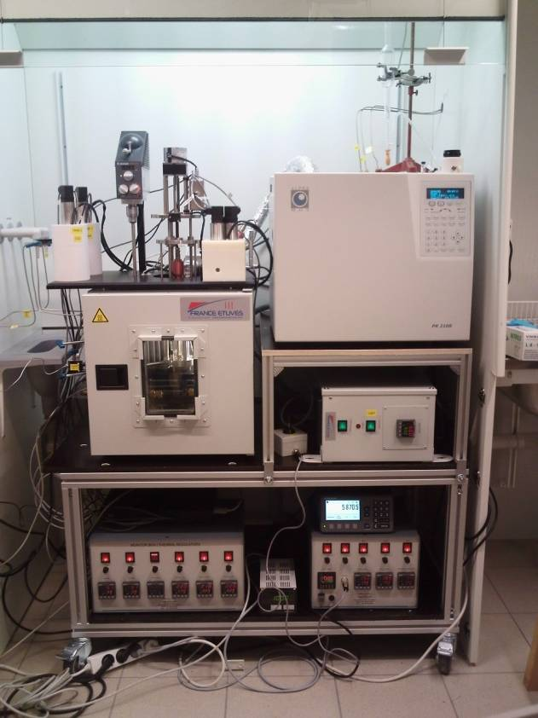
Figure 1. Pictures of low pressure VLE apparatus (left), reactor calorimeter (middle) and high pressure VLE apparatus (right).
State of art for TA1.1, TA1.2 and TA1.3
The installations Ta1.1, TA1.2 and TA1.3 are designed for CO₂ capture research. In-house activity based thermodynamic and kinetic models can be used to model the experimental results. The laboratory has a close co-operation with analytical laboratory (SITNEF Biotechnology), which makes it possible to analyze liquid samples for degradation products and amines. Additionally NMR can be used to find the speciation in the liquid.

Services currently offered by the infrastructure and achievements for TA1.1, TA1.2 and TA1.3
Measurement of thermodynamic data, like VLE and heat of absorption, needed for example in process modeling can be performed. Absorption kinetics including measurement of physical properties is needed for sizing of absorber. Degradation studies will give fundamental understanding of the solvent as well as indicate the solvent make-up costs.
Part of experimental apparatuses have been / are used in CASTOR, CESAR, DeCarbit, ENGAS and iCAP EU-funded projects. There is a close co-operation with SINTEF Materials and Chemistry and a long history of collaboration with the Department of Thermal Engineering, Tsingua University, Beijing and the Department of Chemical Engineering, University of Austin, Texas through exchange of PhD students and research personnel. In the last 5 years, more than 30 peer reviewed journal publications has been published presenting data from these installations.

Selected publications related to TA1.1
Sholeh Ma’mun et al. Kinetics of the Reaction of Carbon Dioxide with Aqueous Solution of 2- ((2Amino(ethylamino) ethanol”, Ind. Eng. Chem. Res., (2007), 46, 385-394
Hartono A. et al. Solubility of N2O in aqueous solution of Diethylenetriamine, J.Chem Eng. Data 2008, 53, 2696-2700
Knuutila, H et al. Kinetics of the reaction of carbon dioxide with aqueous sodium and potassium carbonate solutions. Chemical Engineering Science, Volume 65, Issue 23, 1 December 2010, Pages 6077-6088.
Hartono A et al. Kinetics of carbon dioxide absorption in aqueous solution of diethylenetriamine(DETA), Chem. Eng. Science, 2009, 64, pp 3205-3213

Selected publications related to TA1.2
Kim I. et al. Enthalpy of absorption of CO2 with alkanolamine solutions predicted from reaction equilibrium constants, Chem. Eng. Science, 2009, 64, pp2027-2038
Qin F. et al. Study of the Heat of Absorption of CO2 in Aqueous Ammonia: Comparison between Experimental Data and Model Predictions, Ind. Eng. Chem. Res., 2010, 49(8), pp3776- 3784
Knuutila, H. et al. Vapor-liquid equilibrium in the sodium carbonate-sodium bicarbonate-water-CO2-system, Chemical Engineering Science, Volume 65, Issue 6, 15 March 2010, Pages 2218-2226.
Aronu U.E., et al. Vapor-liquid equilibrium in amino acid salt systems: Experiments and modeling. Chem. Eng. Sci. 2011, 66, 2191-2198
Ma’mun, S. et al. Experimental and Modeling Study of the Solubility of Carbon Dioxide in Aqueous 30 Mass % 2-((2-Aminoethyl)amino)ethanol Solution. Ind. Eng. Chem. Res. 2006, 45 (8), 2505 – 2512.

Selected publications related to TA1.3
Lepaumier, H., et al. Energy Procedia. Comparison of MEA degradation in pilot-scale with lab-scale experiments. 2011, 4, 1652.
Lepaumier, H., et al. Chemical Engineering Science. Degradation of MMEA at absorber and stripper conditions. 2011, 66, 3491.
Eide-Haugmo, I. et al. Chemical stability and biodegradability of new solvents for CO2 capture. Energy Proceedia 4 (2011) pp. 1631-1636.

The replacement costs for the installation of the Infrastructure (€):

Short name of installation | Unit of access | Unit cost (€) | Min. quantity of access to be provided | Estimated number of users or user groups | Estimated number of days spent at the infrastructure | Estimated number of projects
MEMB-FAB | Weeks | 5000 | 32 | 6 | 300 | 6
MEMB-PERM | Weeks | 5000 | 32 | 6 | 300 | 6
ABSKIN | Weeks | 2300 | 30 | 6 | 250 | 6
ABSDEG | Weeks | 1650 | 30 | 6 | 250 | 6
ABSEQ | Weeks | 2300 | 30 | 6 | 250 | 6

